
Torbay Annual Report
Local Authority Designated Officer (LADO)

1st April 2024 to 31st March 2025

Contents
Contents 1
PART ONE 3
Introduction 3
The statutory role of the LADO and national context 3
The key aspects of the LADO role include the following responsibilities: 4
The LADO should be alerted to concerns in which it is alleged that a person who works with children has: 4
Regional/National context 4
Service structure and staffing 5
PART TWO 6
Numbers of Consultations and Referrals 6
Meeting LADO Harm Threshold: 8
PART THREE 10
Trends in Early Years 11
Trends in School/Academies 11
Overall Insights 11
PART FOUR 12
Bar Chart Comparison 13
Overall Insights 13
Potential Factors that may have influenced the change. 13
Significant Effects on Children in Care 14
Overall Impact 15
PART FIVE 16
Profile of work 16
Referral Source and Subject 18
Observations 19
Insights 19
Potential Factors 20
LADO consultations 20
Rise in Harm Percentage: 20
PART SIX 22
Outcomes of Allegations: 22
Overall Implications: 23
Limiting Factors 24
Outcomes 25
Participation and Partnership 25
Complex Matters 25
Training and Service Awareness 26
PART SEVEN 27
Actions for 2025-2026 Summary of Key Actions and Outcomes 27

Acronym List

AMM (Allegations Management Meeting)
DBS (Disclosure and Barring Service)
GDPR (General Data Protection Regulation)
HR (Human Resources)
IFA (Independent Fostering Agency)
IRO (Independent Reviewing Officer)
IT (Information Technology)
LADO (Local Authority Designated Officer)
NLN (National LADO Network)
OFSTED (Office for Standards in Education, Children’s Services and Skills)
QA (Quality Assurance)
SARS (Safeguarding and Reviewing Service)
TSCP (Torbay Safeguarding Childrens Partnership)

PART ONE

Introduction
This report outlines the activities and responsibilities of the Torbay Local Authority Designated Officer (LADO) for the period from April 2024 to March 2025. In collaboration with statutory agencies such as children’s social care and the police, the LADO is tasked with managing and overseeing the processes for handling allegations of abuse against individuals working with children and young people in positions of trust.
The report provides a comprehensive overview of the allegations referred to the LADO service concerning individuals in a position of trust, whether they are employed or volunteering, within the Torbay area.

The statutory role of the LADO and national context
The LADO responsibilities are set out in Working Together to Safeguard Children (2023) and Keeping Children Safe in Education (2024)

Working together to safeguard children - GOV.UK (www.gov.uk)

Keeping children safe in education - GOV.UK (www.gov.uk)

For all other organisations, the procedure falls within the Southwest Child Protection Procedures:

https://torbaychildcare.proceduresonline.com/local_resources.html

The key aspects of the LADO role include the following responsibilities:
- To coordinate the safeguarding and investigative process in response to allegations made against individuals working with children.
- To provide advice/guidance to employers or voluntary organisations.
- To consult with Police and other agencies including OFSTED and professional bodies such as the General Medical and the General Teaching Council.
- To monitor the progress of referrals/consultations to ensure they are dealt with as quickly as possible, consistent with a thorough and fair process.
- To resolve any inter-agency issues.
- To collect strategic data and maintain a confidential database in relation to allegations.
- To disseminate learning from LADO enquiries throughout the children’s workforce.
- To ensure that measures are in place to prevent further harm or abuse and that where required, referrals/consultations are made to the appropriate social care team.

The LADO should be alerted to concerns in which it is alleged that a person who works with children has:
- Behaved in a way that has harmed, or may have harmed, a child.
- Possibly committed a criminal offence against children or related to a child.
- Behaved towards a child or children in a way that indicates they may pose a risk of harm to children; or
- Behaved or may have behaved in a way that indicates they may not be suitable to work with children.

Regional/National context.

The LADO continues to take an active role in the regional Southwest LADO and National LADO network meetings to share learning and improvement.

Close informal arrangements within the regional LADO network include peer observations and audits and continued regular network meetings to support service-led improvement and strengthen effective cross-boundary working.
The LADO is consistent and complies with statutory guidance and the Southwest Child Protection Procedures. Additionally, the forum is used to share information, best practice and lessons learned from each other’s professional experiences as well as learning from serious case reviews. This forum enables the identification of training needs and input into policy development at a local and national level.

All information held by the LADO Service is compliant with Data Protection Act (2018) and General Data Protection Regulations (GDPR). Information is retained in accordance with the Council’s retention policy.

Service structure and staffing.

In Torbay, the LADO service consists of one full-time position, supported by business administration, and the role is integrated within the Safeguarding and Reviewing Service (SARS). The LADO rota is managed by Independent Safeguarding Reviewing Officers (IRO), ensuring additional resilience and coverage during any periods of sickness and/or annual leave of the LADO.

The Safeguarding & Quality Assurance Service Business Support Office provides administrative support. Their responsibilities include:

- Maintaining an up-to-date database, including consultations and referrals.
- Organising LADO meetings and reviews.
- Liaising with partner agencies, as necessary.
- Securely distributing minutes from any LADO meeting.

Management Oversight
Torbay Council ensures effective management oversight by incorporating elements of quality assurance, LADO supervision, addressing emerging areas of concern in individual concerns, and facilitating improvements in LADO practices.

PART TWO

Numbers of Consultations and Referrals
Referrals
The LADO receives enquiries from various sources, primarily in the form of consultations or referrals. All consultations and referrals are meticulously recorded on a spreadsheet which is held within the LADO database. Since June 2021, the Torbay LADO service has utilised Liquid Logic as its secure IT data system.
Consultations and Referrals over period of three years (2022 – 2025)
377

Number of LADO Consultations and Allegations Management meetings
Chaperones Interviews and Information requests

During the period from April 2024 to March 2025, there were a total of 377 consultations, with 39 consultations meeting the LADO harm threshold (307 instances of LADO consultations in total). Additionally, there were 27 chaperone interviews and 43 recorded as information only. This relates to Information request/DBS requests none of which required recording under allegations. Comparatively, in the year 2023-2024, there were 412 consultations with 30 consultations meeting the LADO harm threshold, and in 2022-2023, there were 410 consultations with 30 meeting the threshold.
Key observations indicate a decrease in the total number of consultations from 410 in 2022-2023 to 412 in 2023-2024, to 377 in 2024-2025. The number of consultations remains consistent, with the decrease not significantly below the annual expected figure. Therefore, the LADO service will continue to collect data with regular reporting updates to the database. While this analysis has been conducted annually, to fully understand the value decreases and pinpoint emerging trends, quarterly reports will now be made. Detailed reports will be produced as required.

Meeting LADO Harm Threshold:
The number of consultations meeting the LADO harm threshold has slightly increased from 30 in both 2022-2023 and 2023-2024 to 39 in 2024-2025. This suggests a higher proportion of consultations are meeting the threshold criteria in 2024-25. The majority of activities in 2024-2025 are LADO consultations (307 out of 377), indicating that most interactions are consultative rather than progressing to formal allegations or other categories. Chaperone interviews and information requests are low in number and are not recorded as allegations, highlighting their different nature compared to consultations and referrals.
The impact of awareness training on the role of the LADO and the threshold for referrals into LADO is also likely affecting the reduction in consultations. LADO is very aware of professionals feeling the need to 'check out' with LADO by way of a consultation, to ensure they are meeting the needs of children regarding their safety and wellbeing.

PART THREE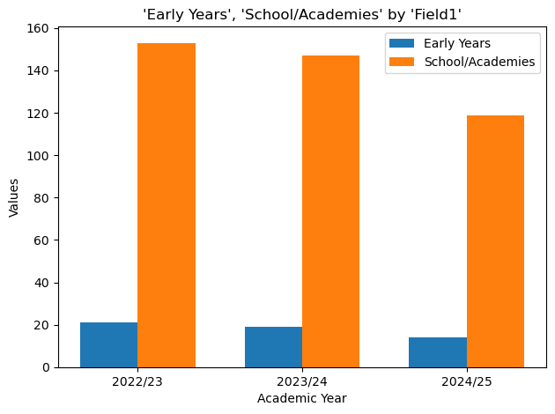
 | 2022/23 | 2023/24 | 2024/25
Early Years | 21 | 19 | 14
School/Academies | 153 | 147 | 119

Based on the data from the bar chart above, here are some insights:
The values for Early Years have steadily decreased from 21 in 2022/23 to 14 in 2024/25. This suggests a reduction in the metric being measured for Early Years over the three academic years. Similarly, the values for School/Academies have also decreased from 153 in 2022/23 to 119 in 2024/25. Although the decline is less steep compared to Early Years, it still indicates a downward trend. Both categories show a consistent decline over the three years, which could indicate broader issues affecting both Early Years and School/Academies, such as funding cuts, changes in policy, or other external factors. The decline in School/Academies is more significant in absolute terms compared to Early Years, however, proportionally, Early Years has seen a sharper decline.

PART FOUR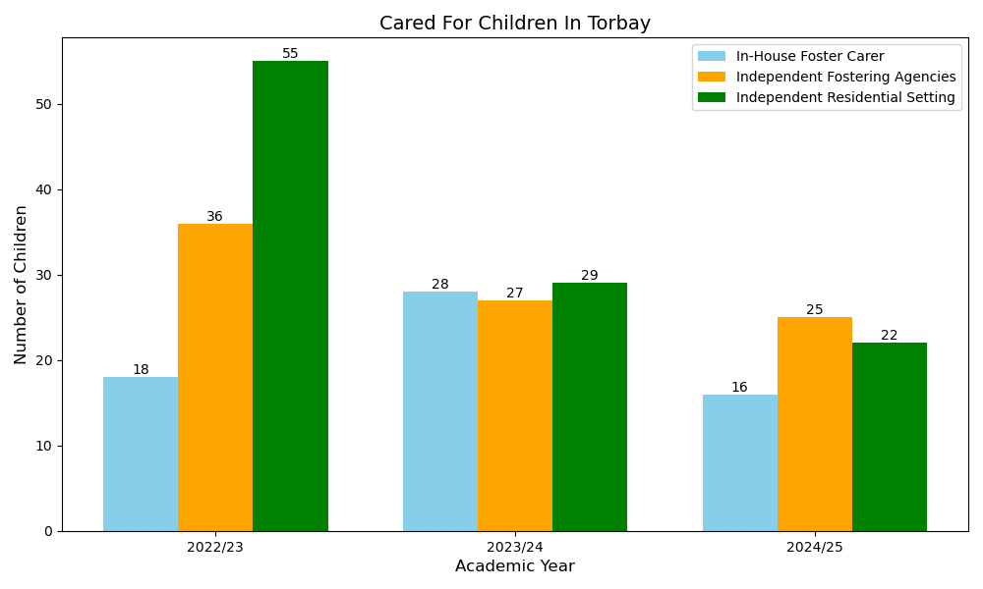
Year | In-House Foster Carers | Independent Fostering Agencies | Independent Residential Setting | Total
2022/23 | 18 | 36 | 55 | 109
2023/24 | 28 | 27 | 29 | 84
2024/25 | 16 | 25 | 22 | 63

Overall Insights
The In-House Foster Carers category demonstrates fluctuations with an increase in 2023/24 and a decrease in 2024/25, while the other two categories show a consistent downward trend. Both Independent Fostering Agencies and Independent Residential Settings have seen significant declines over the last three years, with the most pronounced drop in Independent Residential Settings with regards to allegations. This is linked to the fact that there are less Torbay cared for children placed in residential settings and the fact that there are a relatively low number of residential settings in the region.

Potential Factors that may have influenced the change:
- Policy Changes: Changes in policies related to foster care and residential settings might be influencing these trends. For example, changes in recording practices were implemented following legislation in 2020 through ‘Keeping Children Safe in Education’, which saw the addition of the suitability criteria. This criterion identifies types of behaviour from staff that may indicate a person poses, or might pose, a risk of harm if they continue to work in regular or close contact with children. This is commonly known as the ‘harm test’: a person has ‘behaved or may have behaved in a way that indicates they may not be suitable to work with children.’ For LADOs, this addition was intended to capture a broader range of behaviours indicating risk, where an incident occurs outside of work and did not involve children but could impact their suitability to work with them.
- In addition to this, the management of low-level concerns was introduced in 2021, regarding behaviour that does not meet the above thresholds but still presents significant concerns which is referred to as low-level concerns. At the time, revisions helped distinguish between managing concerns that met the threshold and low-level concerns.
- Funding: Different levels of funding can affect the availability of resources such as trained personnel, support services, and investigative tools. For example, underfunded areas may struggle to maintain adequate staffing levels, leading to delays in handling allegations and potentially less thorough investigations. Adequate funding ensures that staff receive regular and comprehensive training on safeguarding practices, including how to recognise and report allegations.
- Demand and Supply: Variations in the demand for different types of care and the availability of resources can significantly impact referrals and consultations to the LADO. Issues such as the availability of trained personnel directly affect the capacity to manage allegations effectively.

Significant Effects on Children in Care
In-House Foster Carers:
- Instability: Fluctuations in the availability of in-house foster care can lead to instability for children. Consistent and stable placements are crucial for their emotional and psychological well-being.
- Quality of Care: If resources for in-house foster carers are inconsistent, it might affect the quality of care provided. Children might not receive the consistent support they need for their development.
Independent Fostering Agencies:
- Reduced Options: Independent Fostering Agencies provide comprehensive training for foster carers, which is crucial for effectively reporting allegations. Should sufficiency of such placement options reduce, this could impact on the number of consultations received to the LADO.
- Impact on Services: Agencies facing financial or operational challenges might struggle to provide high-quality services, affecting the overall care experience for children.
Independent Residential Setting:
- Limited Availability: Stringent regulatory and licensing requirements can make it difficult for new residential settings to open and for existing ones to expand. Compliance with these regulations requires significant investment in time and resources. When suitable placements are not available, children may be placed in settings that do not meet their specific needs. This can lead to dissatisfaction, behavioural issues, and a higher likelihood of allegations being made.
- Quality and Accessibility: Reduced availability might also impact the quality and accessibility of residential care, potentially leading to unmet needs and negative outcomes for children.

Overall Impact
Instability and reduced options in care placements can have a profound impact on the emotional and psychological well-being of children. Consistent, high-quality care is essential for their development and sense of security. Frequent changes in placements or inadequate care can disrupt children's education and social development, affecting their long-term prospects.
This instability can be linked to a higher likelihood of allegations of harm, as children in unstable care placements are more vulnerable to abuse and neglect. The lack of consistent oversight and support increases the risk of harm. Children who experience frequent changes in placements may be more likely to report allegations due to their heightened sense of insecurity and need for protection.
Therefore, ensuring that children in care have access to safe and supportive environments is crucial. Any decline in the quality or availability of care can compromise their overall health and well-being. Where there is a high staff turnover in care settings can lead to inconsistencies in care and supervision, resulting in a lack of continuity in safeguarding practices and increasing the risk of incidents and allegations.

PART FIVE

Profile of work
The bar chart provided evidences the types of Referrals and shows data for three academic years: 2022/23, 2023/24, and 2024/25. It includes different categories of referrals such as Behaviour, Emotional, Neglect, Physical, Sexual, Transferable Risk, and Other.
Type of Referrals (Reason for Consultation with LADO)

This 2024/25 academic year showed a significant rise in referrals relating to Behaviour, reaching 108. Emotional decreased to 10, Neglect to 11, Physical to 80, Sexual to 28, and Transferable Risk referrals to 69. This data indicates notable trends and changes in the types of referrals over the three years, with a particularly sharp increase in referrals relating to the behaviour of adults in positions of trust in the most recent year. Several factors could influence the trends in referral types shown in the bar chart.

Changes in School Policies: Schools may have implemented new policies or programs aimed at identifying and addressing specific issues, such as behavioural problems or emotional distress, leading to an increase in referrals in those categories.

Increased Awareness and Training: Teachers and staff may have received improved training on recognising signs of neglect, physical abuse, or emotional issues, resulting in more referrals as they become more vigilant.

Reporting Mechanisms: Improvements in reporting mechanisms and easier access to referral processes can lead to an increase in the number of referrals. If it is easier for staff to report concerns, they may do so more frequently.

Parental Involvement: Increased involvement and awareness amongst parents regarding their children's well-being can lead to more referrals as parents advocate for their children’s needs.

Referral Source and Subject

Observations
- Education: The highest number of referrals come from the education sector, with 120 referrals. This indicates that schools and educational institutions are a major source of concerns reported to the LADO. This maybe that schools are likely to ‘run things past’ the LADO order to have a clear record to evidence of sharing information whereby patterns of concerns are identified and triangulating of information requests in relation to specific settings prior to OFSTED inspections.
- Torbay Council: The second highest number of referrals come from Torbay Council, with 85 referrals, showing significant involvement from local government. This highlights an increase in awareness from childrens social workers specifically across Torbay council to refer.
- Police: Police also play a crucial role in referring concerns to the LADO, with 49 referrals. The police have a close working relationship with the LADO which greater supports their understanding of allegations process.
- Other Categories: Categories such as Health, Other Local Authorities, Fostering, and Sports have moderate numbers of referrals, whereas categories like Public, Faith, and Early Years have significantly fewer referrals. This suggests a need to enhance awareness and training among these groups to ensure they are adequately informed and equipped to handle safeguarding concerns.
- Negative Values: Categories such as CAFCASS, OFSTED, and Adult have negative values, which might indicate data entry errors or specific concerns where referrals were retracted or found to be unfounded.

Insights
- High Referral Sources: Education and Torbay Council are the primary sources of referrals, suggesting that these sectors have robust mechanisms for identifying and reporting concerns.
- Moderate Referral Sources: Police, Health, Other Local Authorities, Fostering, and Sports contribute significantly but less than Education and Torbay Council.
- Negative Values: The presence of negative values in some categories suggests a need for data review and validation to ensure accuracy.

All consultations are recorded for future reference if any further enquiries arise relating to any named adult.

Category | Count
Met Harms Threshold | 39
Does Not Meet LADO Threshold | 176
Referred to another Local Authority | 12
Does Not work with child | 9
Info and Advice | 71
Chaperone Interviews | 27
Other: Info Request | 43
Total | 377

The large number of consultations, even those not meeting the threshold, has the potential to impact on the LADO service capacity, based on the importance of recording each consultation for reference for the future if any named individual has a repeat consultation brought to the LADO’s attention. Each consultation requires a lot of administrative work, in respect of logging and evaluating information, which takes time.

These are some of the themes that highlight the complexity and variability in the decision-making process for progressing consultations. These highlight the complexity and variability in the decision-making process for progressing consultations. One reason for the high number of consultations is Ofsted's requirement for regulatory settings to report all incidents of inappropriate staff behaviour to LADO. Below are other considerations:

- Basic Fact Finding: Often, initial consultations involve gathering basic facts which can reveal that concerns are unfounded. This can lead to the decision that no further action is necessary.

- Referrer Policies: Some organisations have blanket policies to refer cases to the LADO for an independent view, even if they believe the threshold is not met. This ensures impartiality and thoroughness in handling potential concerns.

- Issues related to administrative processes, such as incomplete documentation or procedural errors, can also prevent consultations from progressing and sometimes, the personal biases of professionals involved can influence the decision-making process, leading to a conclusion that the threshold is not met.

- At time there can be a level of uncertainty about the situation, or the specific context of the patient can also play a role in not meeting the threshold.

PART SIX

Outcomes of Allegations:

Allegations Management Meetings (AMM)

Managing Allegations Meeting refers to the multi-agency meeting process in respect of the individual who is subject of the allegation or concern. The person who is the subject of the allegation or concern is referred to as the ‘person of concern.’ At the final meeting, members will decide whether the allegation is:

1. Substantiated – where there is sufficient identifiable evidence to prove the allegation.
2. False – where there is sufficient evidence to disprove the allegation.
3. Malicious – where there is clear evidence to prove there has been a deliberate act to deceive and the allegation is entirely false.
4. Unfounded – where there is no evidence or proper basis which supports the allegation being made. It might also indicate that the
person making the allegation misinterpreted the incident or was mistaken about what they saw. Alternatively, they may not have.
been aware of all the circumstances.
5. Unsubstantiated - This is not the same as a false allegation. It means that there is insufficient evidence to prove or disprove the allegation. The term, therefore, does not imply guilt or innocence. Where concerns are unfounded or unsubstantiated, it may still require further internal investigation by the employer or other action to be taken and does not necessarily mean there are no concerns at all.

The following table displays the outcomes of Allegations Management Meetings held with the last three years for comparison:

 | 2022/23 | 2023/24 | 2024/25
Unfounded | 4 | 10 | 4
Malicious | 0 | 0 | 0
False | 0 | 0 | 0
Unsubstantiated | 11 | 7 | 20
Substantiated | 15 | 9 | 8
Pending outcome |  | 4 | 7

There has been small increase in reports that did not meet the criteria for further action. The absence of any perceived malicious referrals across all three years is a positive sign, indicating that there are no intentional false reports being made. The significant rise in unsubstantiated referrals in 2024/25 indicates potential challenges in gathering sufficient factual evidence to support the referral being made. The decrease in substantiated referrals over the three-year period suggests that fewer incidents are presenting with adequate evidence to prove harm, considering also that the number of referrals that have been substantiated still remain relatively low over the three-year period. This may be because the LADO guides and informs organisations prior to contacting the LADO formally that they should conduct basic enquiries in line with local procedures to establish the facts and help determine whether there is any foundation to the allegation, being careful not to jeopardise ay future police investigation. For example, whether:
- the individual was in the school or college at the time of the allegations.
- the individual did or could have come into contact with the child.
- there were any witnesses, and
- there is any CCTV footage.
Looking at the highest number of outcomes being unsubstantiated the LADO includes whether or not any lessons can be learned, and improvements can be made to the organisation process.

Pending Outcome:
The introduction and increase in pending outcome referrals from 2023/24 to 2024/25 indicates that more investigations are taking longer to conclude. This is as a result of an increase in complex investigations, alongside delays in police processes being completed.

Overall Implications:
Resource Allocation: The fluctuations in case types suggest a need for adaptable resource allocation to handle varying volumes and complexities of referrals.
Training and Awareness: The trends highlight the importance of ongoing training and awareness programs to ensure accurate reporting and effective handling of consultations and referrals.
Process Improvement: The data suggests areas where the reporting and investigation processes could be streamlined or improved to handle matters more efficiently and effectively.

Timescales to Close Consultations
The statutory guidance mandates that all consultations be resolved promptly, ensuring a fair and thorough investigation. A key aspect of the LADO's role is to manage and oversee all consultations and referrals, ensuring that involved agencies and organisations avoid unnecessary delays.
There are several factors that make these timescale targets challenging to achieve including:

- The duration required for a referral to progress through the criminal justice process to its conclusion.
- Employers awaiting the outcome of a criminal investigation before initiating formal disciplinary procedures.
- Practical considerations, such as the unavailability of individuals for interviews.
- The capacity of the LADO to monitor and follow up on processes being implemented, such as disciplinary investigations by the employer.

Outcomes

- Participants are informed of the outcome by the referrer.
- Young people may also be notified in writing about the outcome, depending on the suitability of this in individual circumstances.
- It is not always appropriate for the referrer to be informed of the outcome, such as when the referrer is a member of the public, however they are assured that the information they provided has been handled appropriately.
- The LADO service manages sensitive information and seeks guidance on sharing this information as appropriate through line manager, Information Governance team and HR colleagues.

Participation and Partnership
The LADO service continues to collaborate closely with various agencies. Information and guidance are available on the Torbay Safeguarding Children’s Partnership (TSCP) website to enhance understanding of the LADO role.

Following the redevelopment of the TSCP website, additional resources have been included, to provide comprehensive support and clarity regarding the LADO process. This includes:

- Advice for organisations
- Attending a LADO Allegations Management Meeting
- What happens when an allegation is made against you.
- Addressing concerns raised about you in your personal life.

Complex Matters
The LADO service occasionally addresses concerns of a sensitive nature that may attract public interest, either due to the media profile of an individual or because of information that raises concerns about an organisation's broader safeguarding practices. In such matters, the LADO service provides alerts and updates to Senior Managers, who are responsible for managing information with the media and/or co-ordinating strategic responses.

Training and Service Awareness
Raising the profile of the LADO role across the partnership has continued to be a focus during the reporting year. The LADO service continues to undertake a series of virtual presentations on the role of the LADO to Early Years, Education Leads, and Fostering Agencies.

The training includes an overview of the LADO role, the process of managing allegations, and how staff can protect themselves from allegations. This has raised awareness among those in the children’s workforce regarding appropriate behaviour and safe practices, resulting in timely responses to incidents and professionals feeling more confident in contacting the LADO for advice and support before matters escalate.

The LADO Service in Torbay advocates for the importance of safer working cultures that protect children both dynamically and proactively. This includes ensuring adherence to safer recruitment practices and advocating for all within organisations. The Torbay LADO service provides joint safer recruitment training with HR and offers high-quality advice to organisations to consider risks and allegations as they occur. Additionally, the service supports organisations in improving their recruitment processes and developing a safer working culture for the children and young people they serve.

Peer Audits

Annual peer audits have been arranged with the Southwest LADO Group, introducing peer audits involving each local authority across the Southwest. The Torbay LADO service attends these monthly group meetings, which take place virtually.

The Southwest Group is developing several templates to standardise reporting across the region, including a template for the LADO Annual Report and a model for other organisations to complete their investigations. Other developments this reporting year have included the introduction of the LADO Tri-X regional procedures and a peer auditing program, which includes a moderation group.

Additionally, the Torbay LADO service is embedded in the National LADO Network.

PART SEVEN

Actions for 2025-2026 Summary of Key Actions and Outcomes

- Quality Assurance with File Audits of LADO matters: A Performa has been created to review processes and decision-making, ensuring consistency in LADO operations and service provision. Outcome: Ongoing/partially completed.

- Collaboration with Local Safeguarding Partnership: Continued efforts to assess safeguarding issues within the secure estate, ensuring appropriate scrutiny and support for the care of children. Outcome: Continued work.

- Feedback from Young People: Ongoing efforts to seek feedback from young people regarding their experiences with Torbay LADO services. Outcome: Continued work.

- Information Sharing with Safeguarding Partnership and Police: Ensuring information sharing when criteria are met for serving officers and developing closer relationships with the DBS department. Outcome: Ongoing/partially completed.

- Development of LADO Induction Pack: Creating a comprehensive induction pack to assist Duty LADOs in understanding all aspects of LADO services. Outcome: Ongoing/partially completed by the National LADO Network.

- Collaboration with Key Agencies: Exploring closer collaboration with the Teacher Regulation Authority, Social Work England, and Disclosure Barring Service to receive outcomes of referred LADO matters. Outcome: Ongoing/continued.

- LADO Handbook: Sharing the LADO handbook with senior management to outline roles and responsibilities in managing allegations and serious concerns. Outcome: Ongoing.

- Development of Better Practices: Progressing with the development of better practices in collaboration with Children’s Services Commissioning and regional partners to address information and concerns systematically and timely. Outcome: Ongoing/continued.

Completed by: Ivan Sullivan
Dated: 17.06.2025

