Babies Cry, You Can Cope!

I= Infant crying is normal
C= Comforting methods can help
O= It’s OK to walk away
N= Never, ever, shake a baby

is an evidence-based programme ( ICON Programme ) designed to support parents and carers to help them cope with a crying baby. Research points to persistent crying in babies being a potential trigger for some parents/caregivers to lose control and shake a baby, with devastating consequences.

The aim of the programme.
- To Prevent abusive head trauma in babies caused by shaking.
- To Provide advice on how to comfort a crying baby.
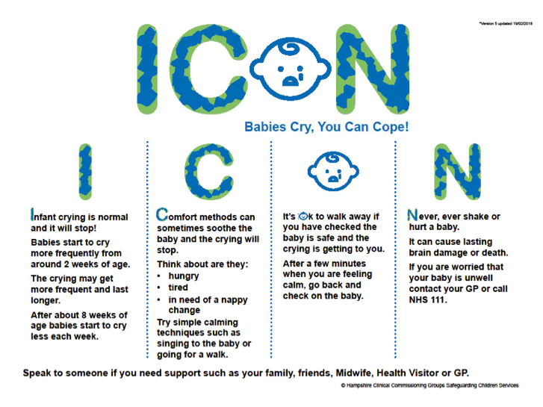
- Explore how to cope when it goes on for a long time.
ICON Resources –

There are numerous resources available on the ICON website for both professionals and parents.
ICON are delighted to work in partnership with DadPad on important matters affecting dads and their children. DadPad offers essential parenting skills for new dads.

Don’t forget, if you are worried that your baby may be unwell, contact your GP, Health Visitor, Midwife or NHS 111 for further advice.

