TURNING CORNERS REFERRAL FORM
Before completing the referral form please ask yourself the following three questions. If your answers are all yes please continue with the form, if not then it is unlikely the subject is appropriate to be assessed by the Youth Exploitation Tracking Assessment (YETA).
- Under 18 at the point of referral save for those already encompassed within the previous projects to maintain intervention and support. Where additional needs are identified in relation to an individual this age limit may be extended to 21.
- At risk of Child Criminal Exploitation outside of the home OR
- At risk of, or currently engaging in violence / disorder outside of the home.

Please note this does NOT replace any pre-existing Statutory Processes. If any other referrals have been submitted to other processes please detail within the referral with referral dates and outcomes.
First Name
Surname
DoB
Address

URN (if known)
PNC ID (if known)
Area Frequents | South Devon / Torbay
Town Frequents
Parent/Guardian Name
Parent/Guardian Contact Number
School Address/
Educational Details
(inc. Safeguarding Lead’s Details)

Social Worker Contact Details & Level of Involvement
(Looked After Child LAC, Child in Need CIN, Child Protection)
Details of Trusted Relationships

Please give as much details as possible including reference numbers and dates.
Circumstances of referral
The Turning Corners Project will work with individuals who are:
- Under 18 at the point of referral save for those already encompassed within the previous projects to maintain intervention and support. Where additional needs are identified in relation to an individual this age limit may be extended to 21.
- At risk of Child Criminal Exploitation outside of the home or
- At risk of, or currently engaging in violence / disorder outside of the home.

Assessment Criteria included within Appendix 1, please consider these areas when completing referral.
- Outline risks that the individual poses to themselves and/or others.
(Where risk to another is identified consider further referral top the Turning Corners Project.)
- Are parents supportive of the referral?
- Is the young person being referred supportive of the young person?
- Has consent to information share been obtained?
- Where consent has not been obtained, have information sharing procedures been explained?
- Is further support for parents required?
- How does the young person view their situation?
- Summary of pre identified trauma and adverse childhood experiences.
- A summary of missing incidents/crime involvement if known.

Details of susceptibility to exploitation outside the home
- Outline risks that the individual poses to themselves and/or others.
(Where risk to another is identified consider further referral to the Turning Corners Project.)
- Are parents supportive of project?

Assessment Criteria included within Appendix 1, please consider and provide detail on these areas when completing referral.

Details of involvement in gang related activity/violence outside the home
- Outline risks that the individual poses to themselves and/or others.
(Where risk to another is identified consider further referral to the Turning Corners Project.)
- The young person’s voice can be completed at any point within the referral process or post referral when level of engagement is achieved and can be obtained by any agency.

Assessment Criteria included within Appendix 1, please consider these areas when completing referral.

Any other relevant information
Assessment Criteria included within Appendix 1, please consider these areas when completing referral.

What does a positive outcome look like for this young person?
As the professional completing this referral what would you consider a positive outcome/positive outcomes for this young person?
What has been tried so far?
What changes does the young person want?
What changes do the family want?

Referrer Name
(Inc. Shoulder Number if relevant)
Department/ Unit
Contact Details

On completion, please send to turningcorners@devonandcornwall.pnn.police.uk
Incomplete forms will be returned to sender
Link to Partnership Referral Form and guidance surrounding submitting intelligence to Police.

Appendix 1 – Assessment Criteria
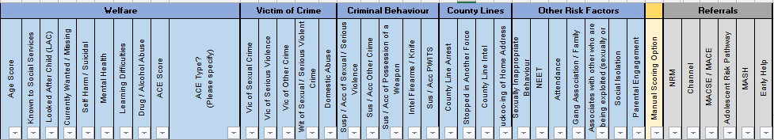
ACE Examples
Please find below a list of example ACE’s:-
Sexual Abuse
Emotional Abuse
Physical Abuse
Neglect
Loss of or Abandonment by a parent
Domestic Abuse
Drug/Alcohol abuse in household
Mental illness in the household
Incarceration of a loved one
Acronyms:-
ACEs – Adverse Childhood Experiences
Vic. – Victim
Wit. – Witness
Susp. – Suspect
Acc. – Accused
Intel. - Intelligence
PWITS – Possession With Intent To Supply
NEET – Not in Education, Employment or Training
NRM – National Referral Mechanism
MACSE/MACE – Missing and Child Sexual Exploitation Forum/Multi-Agency Child Exploitation Forum
MASH – Multi Agency Safeguarding Hub

